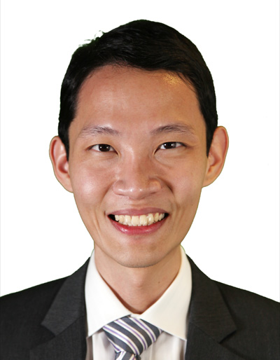

**Shen Jia Xun**

**Blk 7 Haig Road #13-445, Singapore 430007, (+65)97899170,** [**shen.sim.bob@gmail.com**](mailto:shenjiaxun@hotmail.com)

**Education and Qualification**

**Chartered Accountant (Singapore)** (Feb 2015-now)

**Associate Member (CPA Australia)** (Sep 2016-now)

**Bachelor of Accountancy with Second Class Honours (Lower Divison)**  (2008-May 2011)

* Nanyang Business School, Nanyang Technological University (NTU), Singapore
* GPA 3.9/5

**Diploma in Accountancy with Merit**  (2003-2006)

* School of Business and Accountancy, Ngee Ann Polytechnic, Singapore
* GPA 3.83/4

**Work Experience**

**Capitaland** (Apr 2016-now)

Executive

Finance

• Maintaining full set of accounting records of properties within a portfolio.

• Prepare quarterly Singapore Stock Exchange reporting, Board Papers and Statutory Financial Statements reporting.

• Review budgets and forecasts, including collaborating with investment and property managers.

• Review cash-flow forecast and working with treasury to manage cash-flow.

• Standardization and improvement of finance processes and procedures, and updating finance team on accounting developments and regulatory updates.

• Collating and analysis of Singapore-listed REIT financials.

• Assists in preparation of materials for Head of Finance to answer queries in AGM and road shows. Managing finance related questions from investment and property managers and to provide appropriate reconciliations and reports as required.

• Manage an accounting team of four, and meeting various internal and external audit requirements (i.e. tax, accounting and internal controls).

**KPMG** (Aug 2011-Sep 2015)

Senior Associate

Audit and Assurance

* Senior in charge of BHG Retail REIT intial public offering (IPO). Reviewed banker’s financial models. Advised bankers on the level of debt and equity, certain corporate structures, financing structures and avenues to repatriate returns. Prepared proforma financial statements based on different scenerios and assumptions. Assessed client’s forecasts and property valuations, and assisted client in drafting of prospectus.
* Autonomously managed audit engagements across various industries including: funds, real estate developer, construction, hotel, healthcare, advertising, transportation and consumer goods etc. Notable clients:
* Real Estate Capital Asia Partners Fund I,II and III (Close ended opportunitic funds focusing on investing in Asia real estates, mainly in Japan, Korea and Southeast Asia countries) . Assessed valuation of invested properties. Built financial models to test such valuation. Verfied source datas and assumptions used in the valuation. Reviewed the properties for impairment issues. Reviewed consolidated financial statements and partner’s capital, and check for adherence to loan covenants
* City e-Solutions Limited (Lead auditor. Hong Kong listed, operations and investments mostly in The United States. Reviewed consolidation.), W Hotel Singapore, BCH Hotel Investment Pte. Ltd.
* Bukit Sembawang Estates Limited
* GS Engineering & Construction Corporation (Singapore branch)
* National University Hospital (Singapore) Pte. Ltd.
* OMD Singapore Pte. Ltd., PHD Singapore Pte. Ltd.
* Woodlands Transport Holdings Pte. Ltd (Performed consolidation for client.)
* Pepsico International Pte. Ltd., Kao Singapore Private Limited
* Advised audit clients on correct accounting treatments.
* Conversant with International Financial Reporting Standards (IFRS), Singapore Standards on Assurance Engagements (SSAE) and Singapore Standards on Auditing (SSA).
* Identify and communicate accounting, auditing and risk matters to managers and partners.
* Proficient in Microsoft Application

**General Electric Health Care** (May 2010-July 2010)

Intern

Finance and Corporate Comptrollership

* Independently developed analysis templates and tools for cross function cost charging and comptrollership reporting which led to increased efficiency.
* Performed analysis work on accrual provisions and quarter-end revenue and cost evaluation.
* Advised on GST returns, Income Tax Act and Companies Act.
* Utilized strong knowledge of Excel, US GAAP and corporate controllership to contribute to ad-hoc projects in the organization.

**Government of Singapore Investment Corporation** (Sep 2005-Mar 2006)

Intern

Investment Risk Management Department

* Verified bond investment data output and algorithms of IT systems. Conducted user acceptance test for IT systems. Reported on and followed up with vendors on discrepancies discovered.
* Came up with user manual for IT systems.
* Assisted in checking back end and front end of bond investment risk data.

**Singapore Armed Forces, National Service** (Jun 2007- now)

Lieutenant. Signals Officer.

Battalion Signal Officer (Jun 2015- now)

Battalion Deputy Operation Officer (Jun 2007- Jun 2008)

* Planned, developed and wrote operation plan, signal plan and training manual. Coordinated work between various army units.
* Awarded Outstanding Certificate of Service.

**Co-Curricular Activities**

**NTU Hall of Residence 3** (Jul 2008-2011)

* Involved in organizing events such as the freshman orientation camp and hall dinner and dance.

**NTU Divers Club** (Feb 2008-2011)

Member

**Interest and Hobbies**

Running, swimming, SCUBA diving , video editing and building 1:35 scale model kits.